Saturn Class Autumn Term 2023 – Curriculum Newsletter
So, here we are at the beginning of another new academic year! How time flies when you’re having fun! Welcome back and also a very warm welcome to our new families in Saturn Class. The autumn term is always very busy and packed to the brim with learning.
Our timetable has changed slightly, so that we are aligned with Jupiter instead of Mars and as you know, we have a slightly extended school day as we finish at 3:30 instead of 3:20. You will also be aware that we are completely reviewing our homework expectations and we will write to you soon regarding the outcome.
We will set out important dates for the term, and our autumn topics. Should you have any questions, please communicate them via your child’s diary, ask on the door at home-time, or email. nmetcalfe@wincle.cheshire.sch.uk
No question is too big or small!

Mental health and wellbeing
Mental health and well-being continues to be central to our curriculum; it is taught through our PSHE curriculum and through our daily teaching. At the end of the summer, the children designed a new ‘mini-me’ self-portrait to place on our ‘How is your heart feeling today?’ working wall and this seems to be working well to encourage the children to share their feelings with us each morning and at other times throughout the day.
Dojos
We will continue to use our very popular dojo reward system this year to encourage kindness, perseverance and a conscientious attitude. A significant number of dojos are given for working on the crucial skill of reading. Reading at home and recording this in their homework diaries earns children a significant number of dojos. Once again, we will have a dojo shop at the end of term, where they can ‘spend’ their dojos on a variety of small items. For example, pens and pencils, sweets, chocolate or fiddle toys.

Summer Term Topics:
English
In English, we are continuing to use The Write Stuff approach to teaching writing. This involves heavily modelling how to construct different sentences for effect, and using the writing rainbow to support writing. Our first piece will be based on a poem called ‘Autumn is Here’ and so we will be encouraging the children to use lots of rich, descriptive vocabulary to describe the season. This will be followed by a narrative piece based on ‘Stone Age Boy’ by Satoshi Kitamura. Our new class author is Dr Seuss, which will hopefully entertain the children and encourage them to read for fun. We also plan to read ‘Stig of the Dump’ by Clive King as this will link to our writing.
Spelling
The spelling lessons will feel similar to last year, in that we will repeat the same sounds, in the same order week by week. The work will be of a higher level and more challenging as we will cover more advanced vocabulary that meets the requirements for the Y3/4 spelling rules and common exception words.

Maths
In maths, as we do every September, we will begin with revision of place value and then move on to practising the four operations of addition, subtraction, multiplication and division. As you are probably aware, there is a national test (the MTC) in the summer of year four and we will begin practising our times tables skills and knowledge now. As always, practising these number skills with your children at home will really support them to progress in their knowledge.

Science
In science, our topic for this term is ‘Rocks and Soils’. As part of our learning, we are hoping to arrange a trip to Macclesfield Forest to do hands on learning about rocks and soils. We are so lucky that our school is situated so close!

Geography & History
Throughout this year, our history topic will be looking at conflict and how it has changed our civilisation through time. In the first half term, we will begin by looking at Roman Britain, focussing on when the Romans invaded Britain in 43AD!
In geography, we will be linking our learning in history to learn about migration. We will be looking at the different types of migration, migration patterns and the effects of migration across the world and in the past.

RE
In RE this half-term, we will be learning about Good News! We will be studying some of Jesus’ famous parables in the Bible. We will be asking how does the Bible show Jesus living His life as good news? How do stories of Jesus encourage his disciples to live as good news? How do Christians believe that God speaks good news to people through the life of Jesus? After half term, we will begin to learn more about the Christian community. We will focus on how Christians worship God and understand why the Bible is so important to Christians. We will be asking how do we know when someone belongs to a Christian community? How are Christian communities different? What do Christians mean when they use the word church?

Computing
This term in computing, we will be delving further into coding. We will be assembling our own codes and working out errors in pre-made algorithms. After the half term, we will look at spreadsheets, their uses, the different features they have and how they can be useful. Throughout our learning we will be looking at online safety and how we can make sure we are using the internet and technology safely. Pupils are welcome to continue this learning at home by accessing Purple Mash.

Art/DT
The first part of the autumn term we will be focussing on printing. We will begin by studying the work of William Morris, looking at how nature inspired his famous patterns and textiles. At the end of our project, the children will create their own print, inspired by nature.

Music
In music, we will be consolidating last year’s work on beat and rhythm and reading pitch and then developing our knowledge of pitch and tempo further. Following that, we will spend time developing our singing skills in the run up to Christmas

French
In French, we will continue to follow our new curriculum developed by Cave languages, the children will consolidate some of the vocabulary that was introduced last year and develop their speaking, listening, reading and writing skills in French further. We will introduce new colours, greetings, classroom commands and develop our cultural awareness of French-speaking countries.

PE
Saturn will be doing PE on Thursday in in the first part of the Autumn term and on a Monday and Thursday after the half term. On these days, please can the children come to school in their full PE kit. This half-term, we will be doing Swimming on Wednesday and Judo on Thursdays with the our Judo Coach Ann.
PSHE
This term, we will be focussing on and learning about our mental health and emotional wellbeing. We will learn what these things actually mean and positive ways that we can help ourselves! We will continue to look at how important friendships are and how we can make new friendships.

Our timetable for the autumn term:
We have designed two timetables as in Autumn 1, the children will go swimming. Please note that timetables do sometimes have to change to accommodate events throughout the school week.

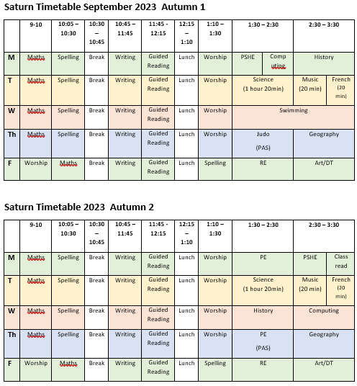

Things to remember:
Monday |  | Things to bring every day:  Homework diary  Reading book  Water bottle  Waterproof coat  Glasses (if worn).
Tuesday
Wednesday | Swimming kit
Thursday | Wear PE kit.
Friday

Dates for the diary:
Wednesday 13th September – Swimming lessons begin
Friday 22nd September – Harvest Festival
Monday 23rd October – Friday 27th October – Half Term Break
Tuesday 14th November Y3 parents are invited to lunch
Tuesday 21st November Y4 parents are invited to lunch
Friday 22nd November break up for Christmas
Thursday 20th July – Break up for the summer

