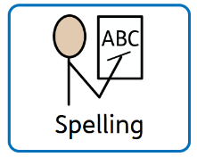
Week 2: Sound of the week ‘e’

Y3/4 Focuses  (Y5/6 will also be tested on these) | Y5/6 Focuses
Spelling Rule:  The ‘sure’ ending  measure, treasure, enclosure, pleasure, leisure, ensure, reassure, unsure, pressure. | Spelling Rule:  The ant/ent, ance/ence ending:  expectant, excellent, elegant, evident, extravagant and others: hesitant, pleasant, accident, inhabitant, patient, magnificent, inhabitant, resistant, restaurant, important, constant.
Common Exception Words:  address, breath, centre, century, experience, experiment, extreme, length, pressure, question, regular, sentence, special, strength. | Common Exception Words:  aggressive, cemetery, competition, correspond, definite, desperate, embarrass, especially, exaggerate, excellent, existence, explanation, leisure, necessary, prejudice, profession, suggest, twelfth.
TASK: Please practise the above rules and words for 10 minutes each day.
Short bursts of regular practice are vital to embed understanding of the patterns and rules.
Task 1– Practise the spelling rules highlighted above and find more examples and possibly exceptions.
Task 2 – Practise the common exception words using the ideas sheet to help you.
You will be tested every Monday on 12 spellings based on the rules and common exception words above.

