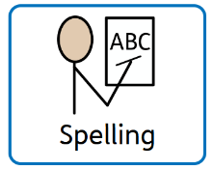
Sound of the week ‘f’
To be tested on Monday 23rd March 2026
Y3/4 Focuses  (Y5/6 will also be tested on these) | Y5/6 Focuses
Spelling Rule:  ‘ph’ making a ‘f’ sound  telephone, paragraph, alphabet, pharaoh, philosopher, epiphany, phonetic, apostrophe, pamphlet, dolphin, photograph | Spelling Rule:  Adding suffixes beginning with vowel letters to words ending in –fer: referring, referred, referral, preferring, preferred, transferring, transferred reference, referee, preference, transference  Words containing the letter-string ough making the ‘uff’ and ‘off’ endings - rough, tough, enough cough
Common Exception Words:  famous, February, forward, fruit | Common Exception Words:  definite, definitely, familiar, foreign, forty, frequently, interfere, physical, sacrifice, sufficient
TASK: Please practise the above rules and words for 10 minutes each day.
Short bursts of regular practice are vital to embed understanding of the patterns and rules.
Task 1– Practise the spelling rules highlighted above and find more examples and possibly exceptions.
Task 2 – Practise the common exception words using the ideas sheet to help you.
You will be tested every Monday on 12 spellings based on the rules and common exception words above.

