

**Asthma Policy Wincle CE Primary School**

Version: APPROVED

Updated: February 2022

**Wincle CE Primary School**

**Wincle**

**Macclesfield**

**Cheshire**

**SK11 0QH**

**Tel: 01260 212592**

**Headteacher: Mrs S Smith**

**Chair of Governors: Dr J Miller**

**www.wincleschool.org**



**Version control**

|  |  |
| --- | --- |
| **Date updated:** | **Brief summary of changes:** |
| February 2022 | Page 3 – punctuation correction to the paragraph titled ‘asthma medicines’. Page 8 – addition of ‘The inhaler will have the full prescription label with date and dosage on it.’  On the parent consent form. |

Our school’s vision:

**Wincle School creates an enriching and outstanding rural education, nurturing the whole individual: body, mind and soul, inspiring rounded, happy, courageous children who exhibit a passion for learning, a confident faith, a loving concern for community and an inclusive respect for all.**

We encourage our pupils to ‘Shine like Stars’ (Philippians 2:15) and to do this run with the following acronym:

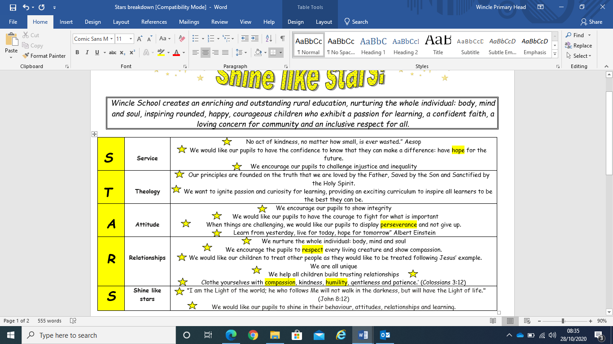

**Wincle CE (A) Primary School Asthma Policy**

**Introduction**

At Wincle school, we:

• recognise that asthma is a widespread, serious but controllable condition and the school welcomes all pupils with asthma

• ensure that pupils with asthma can and do participate fully in all aspects of school life, including art lessons, PE, science, visits, outings or field trips and other out-of-hours school activities

• recognise that pupils with asthma need immediate access to reliever inhalers at all times

• keep a record of all pupils with asthma and the medicines they take

• ensure that the whole school environment, including the physical, social, sporting and educational environment, is favourable to pupils with asthma

• ensure that all staff (including supply teachers and support staff) who come into contact with pupils with asthma know what to do in an asthma attack

• will work in partnership with all interested parties including the school’s governing body, all school staff, school nurses, parents/carers, employers of school staff, doctors, nurses and pupils to ensure this policy is implemented and maintained successfully.

**Background**

This policy has been written with advice from a number of relevant sources including the Department for Education, Asthma UK and the school health service.

**Asthma medicines**

• Immediate access to reliever medicines is essential. Pupils with asthma are encouraged to carry their reliever inhaler as soon as the parent/carer, doctor or asthma nurse and class teacher agree they are mature enough. The reliever inhalers of younger children are kept in the first aid room.

• All inhalers must be labelled with the child’s name.

* If a child experiences an asthma attack which requires medication, this is logged, and parents/carers are informed of the circumstances

**Emergency (Salbutamol) Inhalers**

At Wincle School, an emergency (salbutamol) inhaler is kept in the first aid room along with the required ‘spacers’. These will be administered in the following circumstances:

* A known asthmatic child is having an asthma attack and their own prescribed inhaler is unavailable, out of date, not functioning.
* The attached asthma procedure will be followed and parents informed using the attached letter
* Only children who have a prescribed inhaler will be given the emergency inhaler

At Wincle School, any member of staff may volunteer to take on the responsibility of administering the emergency inhaler, but they cannot be required to do so.

Appropriate training will be provided via the school health service for all staff to include:

* recognising the symptoms of an asthma attack, and ideally, how to distinguish them from other conditions with similar symptoms;
* awareness of the asthma policy;
* awareness of how to check if a child is on the register;
* awareness of how to access the child’s inhaler;
* awareness of how to access and administer the emergency inhaler

**Record keeping**

At the beginning of each school year or when a child joins the school, parents/carers are asked if their child has any medical conditions including asthma on their enrolment form. These medical conditions and any associated medication needs are recorded and copies placed on display in the first aid room. All staff are alerted to this display.

**Exercise and activity – PE and games**

Taking part in sports, games and activities is an essential part of school life for all pupils. All teachers know which children in their class have asthma. Pupils with asthma are encouraged to participate fully in all PE lessons. Teachers will remind pupils whose asthma is triggered by exercise to take their reliever inhaler before the lesson, and to thoroughly warm up and down before and after the lesson. If a pupil needs to use their inhaler during a lesson, they will be encouraged to do so.

**Out-of-hours sport**

There has been a large emphasis in recent years on increasing the number of children and young people involved in exercise and sport in and outside of school. The health benefits of exercise are well documented and this is also true for children and young people with asthma. It is therefore important that the school involve pupils with asthma as much as possible in after school clubs.

School staff and out-of hours school sport coaches are aware of the potential triggers for pupils with asthma when exercising, tips to minimise these triggers and what to do in the event of an asthma attack.

**The School Environment**

The school does all that it can to ensure the school environment is favourable to pupils with asthma. The school does not keep furry or feathery animals and has a definitive no-smoking policy. As far as possible the school does not use chemicals in science and art lessons that are potential triggers for pupils with asthma. Pupils with asthma are supported to leave the room if particular fumes trigger their asthma.

**Liability and indemnity**

*Supporting pupils* requires that governing bodies ensure that when schools are supporting pupils with medical conditions, they have appropriate levels of insurance in place to cover staff, including liability cover relating to the administration of medication. Local Authorities may provide schools which are administering inhalers with appropriate indemnity cover; however, schools will need to agree any such indemnity cover directly with the relevant authority or department.

Appendix 1

**HOW TO RECOGNISE AN ASTHMA ATTACK**

**The signs of an asthma attack are**

* Persistent cough (when at rest)
* A wheezing sound coming from the chest (when at rest)
* Difficulty breathing (the child could be breathing fast and with effort, using all accessory muscles in the upper body)
* Nasal flaring
* Unable to talk or complete sentences. Some children will go very quiet.
* May try to tell you that their chest ‘feels tight’ (younger children may express this as tummy ache)

**CALL AN AMBULANCE IMMEDIATELY AND COMMENCE THE ASTHMA ATTACK PROCEDURE WITHOUT DELAY IF THE CHILD**

* Appears exhausted
* Has a blue/white tinge around lips
* Is going blue
* Has collapsed

Appendix 2

**WHAT TO DO IN THE EVENT OF AN ASTHMA ATTACK**

* Keep calm and reassure the child
* Encourage the child to sit up and slightly forward
* Use the child’s own inhaler – if not available, use the emergency inhaler
* Remain with the child while the inhaler and spacer are brought to them
* Immediately help the child to take two separate puffs of salbutamol via the spacer
* If there is no immediate improvement, continue to give two puffs at a time every two minutes, up to a maximum of 10 puffs
* Stay calm and reassure the child. Stay with the child until they feel better. The child can return to school activities when they feel better
* If the child does not feel better or you are worried at ANYTIME before you have reached 10 puffs, CALL 999 FOR AN AMBULANCE
* If an ambulance does not arrive in 10 minutes give another 10 puffs in the same way

If a child is given their inhaler, their parents will be informed and sign the following sheet.

***Record of medicine administered to all children***

|  |  |
| --- | --- |
| Name of school/setting | Wincle C of E Primary School |

Date Child’s name Time Name of medicine Dose given Any reactions Signature Print name Parent of staff signature

|  |  |  |  |  |  |  |  |  |
| --- | --- | --- | --- | --- | --- | --- | --- | --- |
|  |  |  |  |  |  |  |  |  |
|  |  |  |  |  |  |  |  |  |
|  |  |  |  |  |  |  |  |  |
|  |  |  |  |  |  |  |  |  |
|  |  |  |  |  |  |  |  |  |
|  |  |  |  |  |  |  |  |  |
|  |  |  |  |  |  |  |  |  |
|  |  |  |  |  |  |  |  |  |
|  |  |  |  |  |  |  |  |  |

Appendix 4

**CONSENT FORM:**

USE OF EMERGENCY SALBUTAMOL INHALER

Wincle CE Primary School

**Child showing symptoms of asthma / having asthma attack**

1. I can confirm that my child has been diagnosed with asthma / has been prescribed an inhaler [delete as appropriate].

2. My child has a working, in-date inhaler, clearly labelled with their name, which they will bring with them to school every day. The inhaler will have the full prescription label with date and dosage on it.

3. In the event of my child displaying symptoms of asthma, and if their inhaler is not available or is unusable, I consent for my child to receive salbutamol from an emergency inhaler held by the school for such emergencies.

Signed: Date: ………………………………………………

Name (print)……………………………………………………………………………………………………………………

Child’s name: ………………………………………………………………………………………………………………….

Class: ………………………………………………………………………………………………………………………………

Parent’s address and contact details:

………………………………………………………………………………………………………………………………………..

………………………………………………………………………………………………………………………………………..

………………………………………………………………………………………………………………………………………..

Telephone: ……………………………………………………………………………………………………………………..

E-mail: …………………………………………………………………………………………………………………………….

Appendix 5

LETTER TO INFORM PARENTS OF EMERGENCY SALBUTAMOL INHALER USE

Child’s name: ………………………………………………………………………………………………………………….…………….

Class: ………………………………………………………………………………………………………………………………………….…

Date: ……………………………………………

Dear…………………………………………….,

This letter is to formally notify you that……………………………………….has had problems with his/her breathing today.

This happened when …………………………………………………………………………………………

A member of staff helped them to use their asthma inhaler. They did not have their own asthma inhaler with them, so a member of staff helped them to use the emergency asthma inhaler containing salbutamol.

They were given ……… puffs.

Their own asthma inhaler was not working, so a member of staff helped them to use the emergency asthma inhaler containing salbutamol. They were given ……… puffs. .

[*Delete as appropriate*]

Although they soon felt better, we would strongly advise that you have your seen by your own doctor as soon as possible.

Yours sincerely,