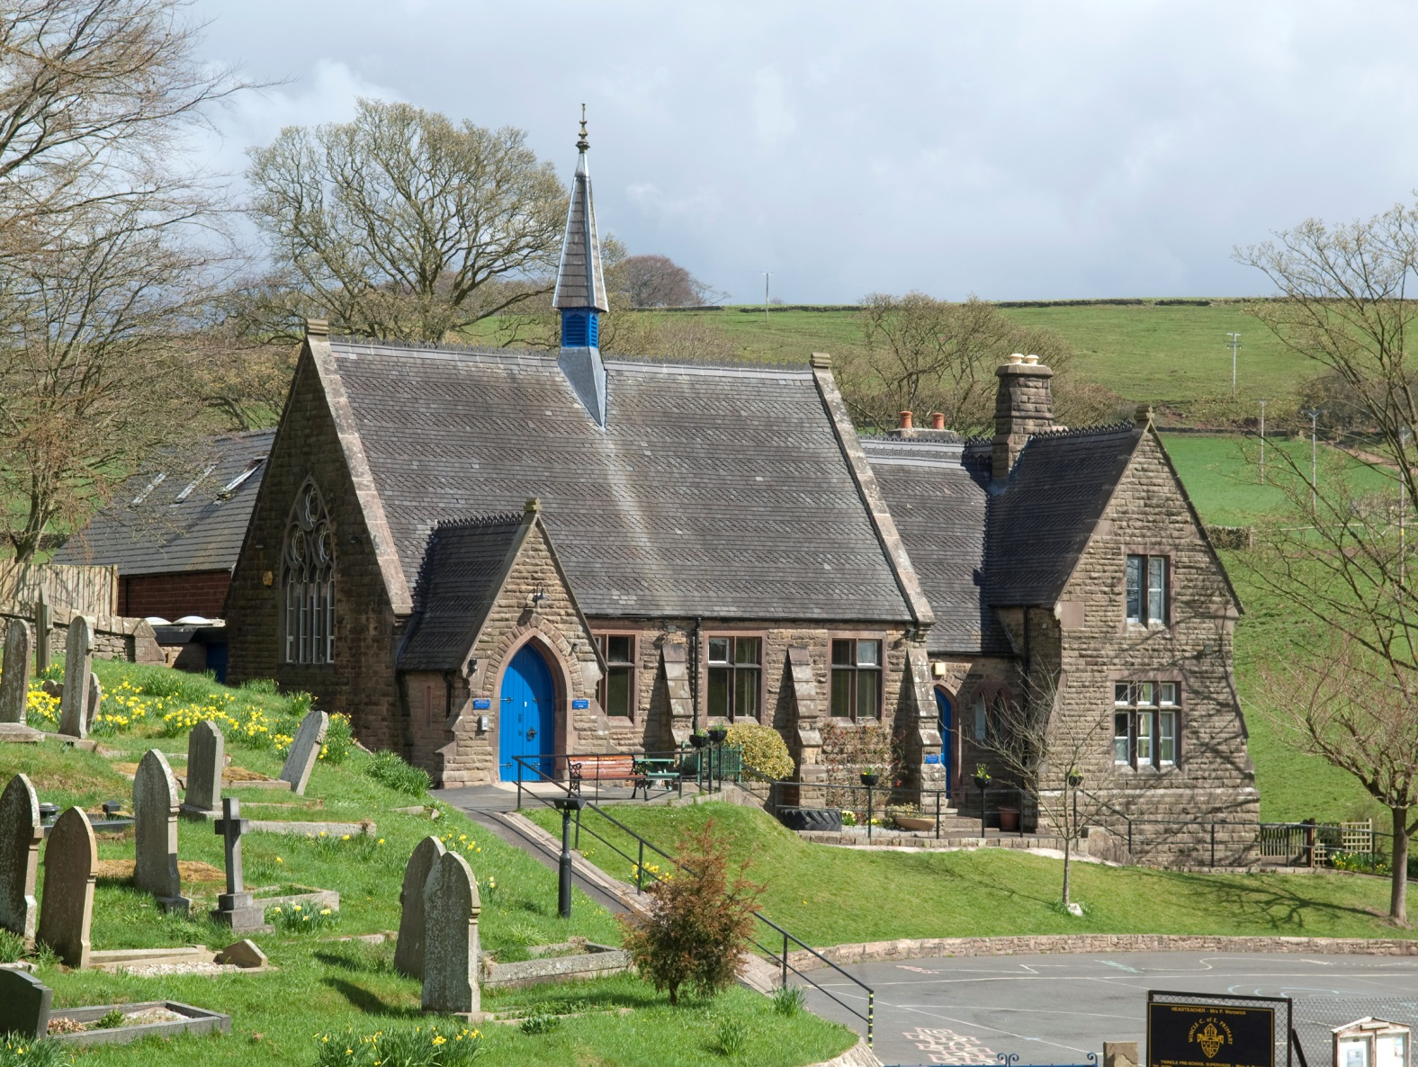

Wincle CE Primary School
Visitor and Intruder Policy
Version: APPROVED
Updated: 16th June 2020
Wincle CE Primary School
Wincle
Macclesfield
Cheshire
SK11 0QH
Tel: 01260 387 387
Headteacher: Mrs S Smith
Chair of Governors: Dr J Miller
www.wincleschool.org

VISITOR AND INTRUDER SECURITY POLICY

GENERAL:
Visitors are welcome, and many, such as parents and suppliers have a right, often legal, to be in the school for legitimate purposes. The Governors have a duty to ensure the safety of everyone on the school site so should ensure that systems are in place to see that this duty is exercised properly. This policy sets out the guidance to Staff on the procedures for routine security and for dealing with trespassers and troublemakers.

PROCEDURES:

ROUTINE SECURITY
- signs at school entrances make clear that visitors should report to Reception
- further signs point the way to Reception
- at reception all visitors must sign in and receive the school’s security
badge, which they must wear at all times in the school.

DEALING WITH STRANGERS
- if a visitor is not wearing a badge he/she should be politely challenged by any member of staff and accompanied to Reception
- at Reception, the administrator should ask the stranger the purpose of the visit, ask them to sign in and issue a badge
- if the member of staff or administrator has any suspicion about the stranger they must inform the Head or the delegated senior teacher on-site immediately, and ask the stranger to remain in the Reception area
- if the stranger ignores the instruction Head or the delegates senior teacher on site must be notified immediately
- if a stranger is abusive, or a nuisance in any way, in the school the member of staff must not take direct action, but MUST send for help, or inform the Head or the delegated senior teacher on-site as soon as this is possible. Staff must never put their own safety at risk.
- only the Head or the delegated senior teacher on-site may ask the stranger to leave the site
- if the stranger refuses the instruction the Head or the delegated senior
teacher on-site may inform the police if he/she considers that there is a
threat to the safety of anyone on the premises. This is entirely a matter
for the judgement of the Head or the delegated senior teacher on site
who will have to judge also whether an incident threatens to undermine
the confidence of parents in the security of the school
- the police cannot arrest an intruder for trespass unless there is a breach of the peace, but have the power of arrest if there is a ‘minor nuisance’. They may be able to help solve the problem without resorting to arrest.

APPENDIX:

A. CONTACTS WITH THE POLICE
- regular contacts will be maintained with the police over security arrangements and crime prevention
- any emergency contact with the police can only be done by the Head or delegated senior teacher in their absence or with the authority of the Head
- when calling the police the Head (or person acting on the authority of the Head) must give clear and sufficient information to allow the police to make a judgement about the scale of their response

B. TYPES OF TROUBLEMAKING
The most common problems facing the school are:
-occasional abusive behaviour from parents
-occasional incursions into the school by outsiders,including former pupils
-former pupils and others waiting outside the schoolgates at the end of school
-occasional vandalism during and outside school hours

C.WHERE THERE ARE OFFENSIVE WEAPONS
INTRUDERS
-if staff suspect an offensive weapon is on site they must immediately inform the Head.
-the person will be kept under close surveillance while the police are awaited

PUPILS
- staff are not obliged to search pupils, but if such a course of action could diffuse the situation it might be contemplated, BUT ONLY BY THE HEAD (or someone with the Head’s authority)
- if the pupil refuses to co-operate, any search should be carried out by the police
- the pupil’s parents must be informed and asked to come to the school
- if the pupil co-operates, at least two teachers of the same sex as the pupil must be present when a search is made. One teacher will do the search while the other observes and takes notes. The search will be in private. It is advisable for parents to be present and to consent, but the pupil’s own consent is sufficient
- any confiscated articles should be handed to the police as quickly as possible by the Head, unless the Head judges that it is reasonable to return it to the parents.
- at all times the suspect pupil must be kept away from other pupils, unless this is not possible owing to the circumstances.

D. REPORTING and RECORDING
- staff must record all incidents in the school incident log, kept in the School Office
- the log will be inspected by the Administrator and the Health and Safety Governor, at regular intervals, and any necessary action taken
- issues will also be discussed by the appropriate sub-Committee of the Governing Body at periodic intervals. This committee may inspect the log as necessary.

E. MONITORING AND REVIEW
The Senior Management Team will monitor the working of the policy and consider annually whether any amendments need to be made.

Wincle CE Primary School’s Visitor Policy
Covid-19 Addendum – June 2020
DfE guidance states that during the Coronavirus Pandemic,
‘Schools should limit the external visitors to the school during school hours.
Parents should come into school buildings only when strictly necessary, by appointment, and ideally only one at a time (unless for example, an interpreter or other support is required). Any such meetings should take place at a safe distance, and so the use of small offices may not be suitable, for example.’
This guidance can be found at https://www.gov.uk/government/publications/covid-19-school-closures/guidance-for-schools-about-temporarily-closing#practicalities
Until further notice, only essential visitors will be allowed into school. This could be:
*Professionals linked to SEN and social care services: educational psychologists, dyslexia assessors, speech and language therapists, occupational therapists and family support workers etc. Visits of this type will be arranged prior to the actual visit with the Head Teacher and SENDCO.
*Maintenance companies who are asked on site to attend to a fault/issue of the school building which is a health and safety risk. Visits of this type will be approved by the Head Teacher.
*Companies who maintain/assess/inspect the school linked to health and safety requirements such as the boiler service, legionella risk assessment and PAT testing. Visits of this type will be approved by the Head Teacher.
*Governors when an online meeting is not possible.
*Parents in the event of an emergency.
All other visitors must be approved by the Head Teacher.
In order to reduce possible transmission of the disease:
*Ask visitors to enter the site before and after the pupils and staff have left.
*Ask all visitors to wear a mask and gloves (supplied by school) which are to be placed in a closed bin bag once the visit is complete. Please note that if gloves make a job difficult, visitors will be asked to use hand sanitizer after completing the job instead of gloves and they will clean the surfaces they have touched.
*All visitors will be kept away from pupils and staff.
*Areas where the visitors have been will be thoroughly cleaned after they have left following the normal cleaning procedures.
Upon entering the building:
*Visitors will be asked if they feel well and if members of their household are well. They will be asked to sign a declaration confirming this.
*Visitors will be asked to sign a declaration to confirm that they have been following government guidance on social distancing.
Upon exiting the building:
*Visitors will be asked to place their mask and gloves in a bin bag which will be sealed and put in the bin of the school office.
*Visitors will be asked if there have been any problems regarding contact with pupils and staff.
*Visitors will be asked to contact the school if they feel unwell in the next two weeks or have to begin self-isolating through the Track and Trace system within the next five days.

Wincle CE Primary School
Wincle School creates an enriching and outstanding rural education, nurturing the whole individual: body, mind and soul, inspiring rounded, happy, courageous children who exhibit a passion for learning, a confident faith, a loving concern for community and an inclusive respect for all.
Wincle School’s Visitor Procedures during the Coronavirus Pandemic.
Welcome to Wincle School
You have been allowed to visit Wincle CE Primary School as your visit has been deemed essential by the governing body – please see the Visitors’ Policy for more information.
Upon entering the school building, please follow these procedures:
*Sign into the visitors’ book.
*Read carefully and sign all declarations.
*Put on a mask and gloves.
Once you have completed your visit, please report to reception and confirm whether or not there have been any problems.
Please contact the school after your visit if:
*You feel feel unwell in the next two weeks or
*Have to begin self-isolating through the Track and Trace system within the next five days.

Visitor Record:
Date: ____________ Name: ________________________________________

I can confirm that I feel well and that all members of my household are also well.

I can confirm that I have adhered to the Government guidelines on social distancing at all times.

Signed: ______________________________________________________

Date: ____________ Name: ________________________________________

I can confirm that I feel well and that all members of my household are also well.

I can confirm that I have adhered to the Government guidelines on social distancing at all times.

Signed: ______________________________________________________

ate: ____________ Name: ________________________________________

I can confirm that I feel well and that all members of my household are also well.

I can confirm that I have adhered to the Government guidelines on social distancing at all times.

Signed: ______________________________________________________

