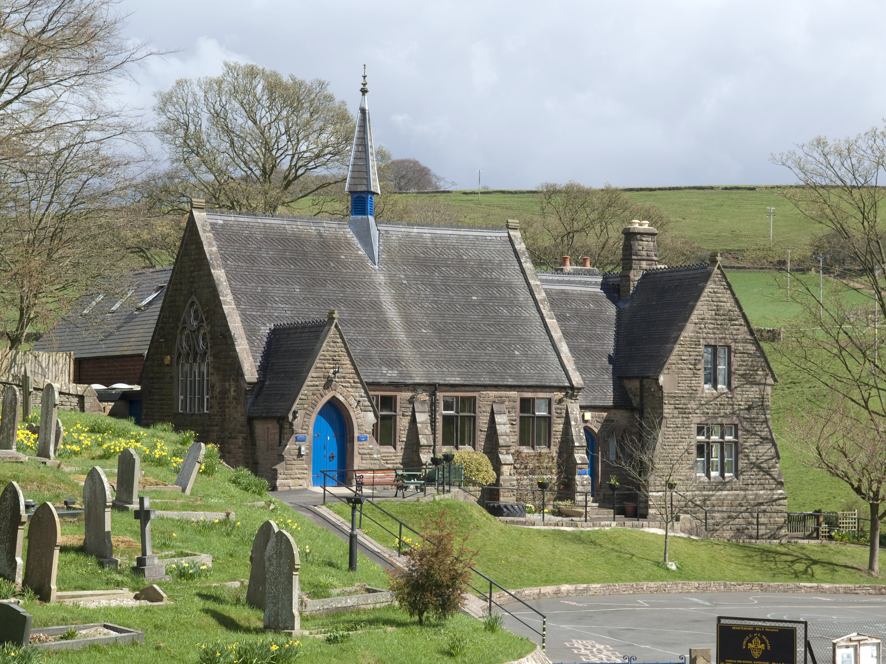

Charging Policy
Wincle CE Primary School

Version: DRAFT

Updated: March 2025

Wincle CE Primary School
Wincle
Macclesfield
Cheshire
SK11 0QH
Tel: 01260 212592
Headteacher: Mrs S Smith
Chair of Governors: Mrs S. Goodwin
www.wincleschool.org
Version control
Date updated: | Brief summary of changes:
March 2025 | Additional information explaining the process undertaken when payments are not made to school.  Change of price for lunches.  Added in cost of breakfast club and All Stars  Benchmarking that has taken place  Added appendix to display benchmarking undertaken

Our school’s vision:
Wincle School creates an enriching and outstanding rural education, nurturing the whole individual: body, mind and soul, inspiring rounded, happy, courageous children who exhibit a passion for learning, a confident faith, a loving concern for community and an inclusive respect for all.
We encourage our pupils to ‘Shine like Stars’ (Philippians 2:15) and to do this run with the following acronym:


Introduction:
The 1988 charging provisions act clarifies and amends existing law which prohibits most charges for activities which take place in school time. The act requires LEAs and Governing Bodies to determine their policy on charging and on remissions within the framework of the legislation, and schools must draw up and maintain a written statement of their policy which must be available to parents on request.

Objectives:
- The objectives of the charging provisions of the 1988 act are:
- To maintain the right to free school education
- To establish that activities offered wholly or mainly during normal teaching time should be available to all pupils regardless of their parents’ ability or willingness to help meet the cost.
- To emphasise that there is no statutory requirement to charge for any form of education or related activity, but to give LEAs and schools the discretion to charge for optional activities provided wholly or mainly out of school hours
- To confirm the right of LAs and schools to invite voluntary contributions for the benefit of the school, or in support of any activity organised by the school whether during or outside school hours.

Current and future charges for school services:

No. | income | Approved charge
1 | School dinners | £2.30 per meal up to 31st August 2025  £2.50 per meal (£2.30 for siblings) from September 2025  Free for pupils whose families are eligible for FSM
2 | Educational visits | For board and lodgings on residential visits *
3 | School Uniform | See appendix for charges
4 | School letting | See school letting policy
5 | Breakfast Club | £2.50 a session up to 31st August 2025  £3.50 a session from September 2025
7 | All Stars Wraparound Care | £3.20 for the first hour up to 31st August 2025  £3.50 for the first hour from September 2025  £8.50 for the full session (this will remain the same in September)
8 | Pre-School | Two-year olds charged at £4.90 per hour  Three/Four-year olds charged at £4.25 per hour

* The LA remits charges for board and lodgings for school visits to Cheshire East’s own outdoor education and residential centres for pupils whose parents are in receipt of income support or family credits. Charges for transport to these centres must be remitted by the school. Schools using non-Cheshire East maintained centres are required to cover from their own budget or school funds the cost of charges remitted for pupils whose parents are in receipt of income support or family credit.

It is the policy of the LA to empower headteachers and governing bodies to receive voluntary contributions, provided it is made clear that any contribution is voluntary and failure to contribute will not involve the relevant parent’s child being treated differently from any other child in the school.

** No child will be prevented from participating in a club due to issues over charging.
Increase in charges:
As a school, we face rising costs due to several factors that impact our ability to provide quality education. Some of the key reasons for increasing costs include:
- Rising Teacher Salaries & Staff Costs - governments regularly revise teacher salaries to attract and retain qualified educators and additional staff (support staff) are often required to meet growing pupil needs.
- Inflation & Operational Expenses - costs for utilities (electricity, water, internet), maintenance, and essential supplies continue to rise.
- Infrastructure Upgrades & Repairs - schools require regular maintenance of buildings, classrooms, and sports facilities.
- Curriculum & Educational Resources - the need for updated teaching and learning material and digital learning tools adds to expenses.
- Compliance with Government Regulations - schools must meet evolving safety, accessibility, and environmental standards.
- Increased Pupil Enrolment - a growing pupil population requires more resources, classrooms, and teachers.
- Technology & Digital Learning Expansion - schools are investing in computers, smartboards, and e-learning platforms to enhance education and cybersecurity and IT infrastructure upgrades are necessary to protect pupil data and ensure smooth online learning.

Managing Rising Costs:
Despite rising expenses, public schools often operate within tight budgets, requiring careful financial planning, government funding adjustments, and potential cost-sharing measures with parents and local communities.
We understand that financial changes can be challenging, and we have worked hard to keep the adjustment to these charges as minimal as possible while ensuring continued excellence in education. If you have any concerns or require assistance, please do not hesitate to contact us at any time.

Importance of Benchmarking Costs Against Other Schools:
Benchmarking school charges against other institutions is a critical practice that ensures fairness, competitiveness, and sustainability. By comparing costs with similar schools, we can:
- Ensure Fair Pricing: Benchmarking helps maintain a balance between affordability for parents and the school's ability to provide high-quality education.
- Stay Competitive: Understanding how other schools structure their fees allows us to offer competitive teaching and learning while maintaining academic excellence.
- Justify Fee Adjustments: It provides a transparent basis for any necessary fee increases by aligning with industry standards and rising operational costs.
- Improve Resource Allocation: Analysing how other schools manage their budgets helps optimise spending on teachers, facilities, and pupil programs.
Regular cost comparisons with other schools help us make informed financial decisions while keeping education accessible and maintaining the high standards expected at Wincle CE Primary School.
Please see appendix B for current benchmarking which took place in spring 2025.

Practicalities for payments:
All money for charges to be paid to the school via the administrative assistant in the school office. The school will ensure it is not acting unlawfully e.g. charging for services for which it is illegal to make a charge. If the school decides to charge more or less than full cost, then the reasons for this must be recorded.

Records will be kept of all letting invoices, numbered sequentially and dated. Records of the income received will be detailed by pay-in slip to LMS budget and linked to invoices.

If lettings result in costs being incurred in repairs, or the replacement of buildings, grounds or equipment, Wincle Primary School understands that the Diocese/Cheshire East Council reserves the right to charge the cost to the school’s delegated budget.

Wincle governing body will ensure that where appropriate, VAT is charged and properly accounted for in accordance with the appropriate VAT regulations (see guidance below)

Guidance on VAT on lettings (in accordance with County Guidelines):
Hire of a room including tables and chairs is exempt from VAT. Except where a separately identifiable charge made for equipment, then hire of equipment becomes standard-rate.

What happens if payments are not made in a timely manner?
It is the School’s policy that every step will be taken to ensure that debts do not occur.
- Every month, the Administration Assistant will communicate with all parents on all money owing. This is reported to the headteacher in a head and admin meeting.
- When a debt remains outstanding at 90 days, the parents will be asked to attend a meeting with the headteacher to discuss the financial situation.
- Where possible, a supportive payment plan will be set up.
- If parents do not engage in this meeting, the school will refer to the local authority and ask them to instigate their long-standing debt procedures. This means that the school will receive the funds from the local authority and they will contact parents for immediate payment.
- If a payment plan is set up but not adhered to, the school will once again, refer to the local authority as in point 4.

Appendix A: School uniform costs March 2025

V neck Sweatshirt up to age 13 | £14.50 | Fleece jacket | £18.50
V neck Sweatshirt adult sizes | £16.00 | Fleece jacket adult | £24
Knitted jumper up to size 32” | £19 | Book bag | £9.99
Knitted jumper size 34” plus | £20.50 | Tie | £7.50
Sweatshirt cardigan up to age 13 | £16.50
Sweat shirt cardigan adult sizes | £18.50
Knitted cardigan up to 32’’ | £20
Knitted cardigan 34’’ upwards | £22
Polo Shirt | £9

Appendix B: Benchmarking

Breakfast Club fees
Name | 7.45-8.45am
Wincle | £2.50
School A | £4.12 (2nd child £2.06 and 3rd child free)
School B | Runs from 8am  £3
School C | 7.30-8.45am  £6.30 (siblings £5.75)
School D | 7.30-8.50am  £5.75 (£5.25 for a sibling)
School E | 7.30-8.45am  £5
School F | 7.30-8.45am  £5.50

After-School Club Fees
Name | 3.30-4.30pm | 4.30-6.00pm
Wincle | £3.20 | £8.50
School A | 3.30-5.30pm  £2.06 for 3.30-4.00pm  £6.18 inc hot snack (2nd child £4.12)  £4.12 for 4.30-5.30pm if attending another club prior (2nd child £2.06)
School B | 3.20-4.30pm  £4.50 per child
School C | Till 5.45pm  £11.80 (siblings £10.70)
School D | £12.50 till 6pm (siblings £12)
School E | £7.50 till 6pm
School F | 3.20-4.30pm at £5.50  3.20-6.00pm at £9.50

School Lunches
Name | Charge
Wincle | £2.30
School A | £2.40
School B | £3
School C | £2.65
School D | £3.20
School E | £3.20
School F | £3.20
School G | £3.20
School H | £2.80
School I | £2.93
School J | £3.20
School K | £2.70
School L | £3.20
School M | £2.70
School N | £2.75

Preschool Fees
Name | 2 YO Costs per hour | 3/4 YO Costs per hour
Wincle | £4.90 | £4.25
School A | N/A | £5.00
School B | N/A | £12 per session +£2.50 (inc lunchtime)  £26.50 full day (exc lunch)
School C | N/A | £14 per session  £27.59 full day
School D | N/A | £6.50
School E | £4.85 | £4.50
School F | N/A | £17 per 3 hour session  £32.50 full day
School G | N/A | £17.00 per session  £34 per day
School H | £6.30 | £5.50

