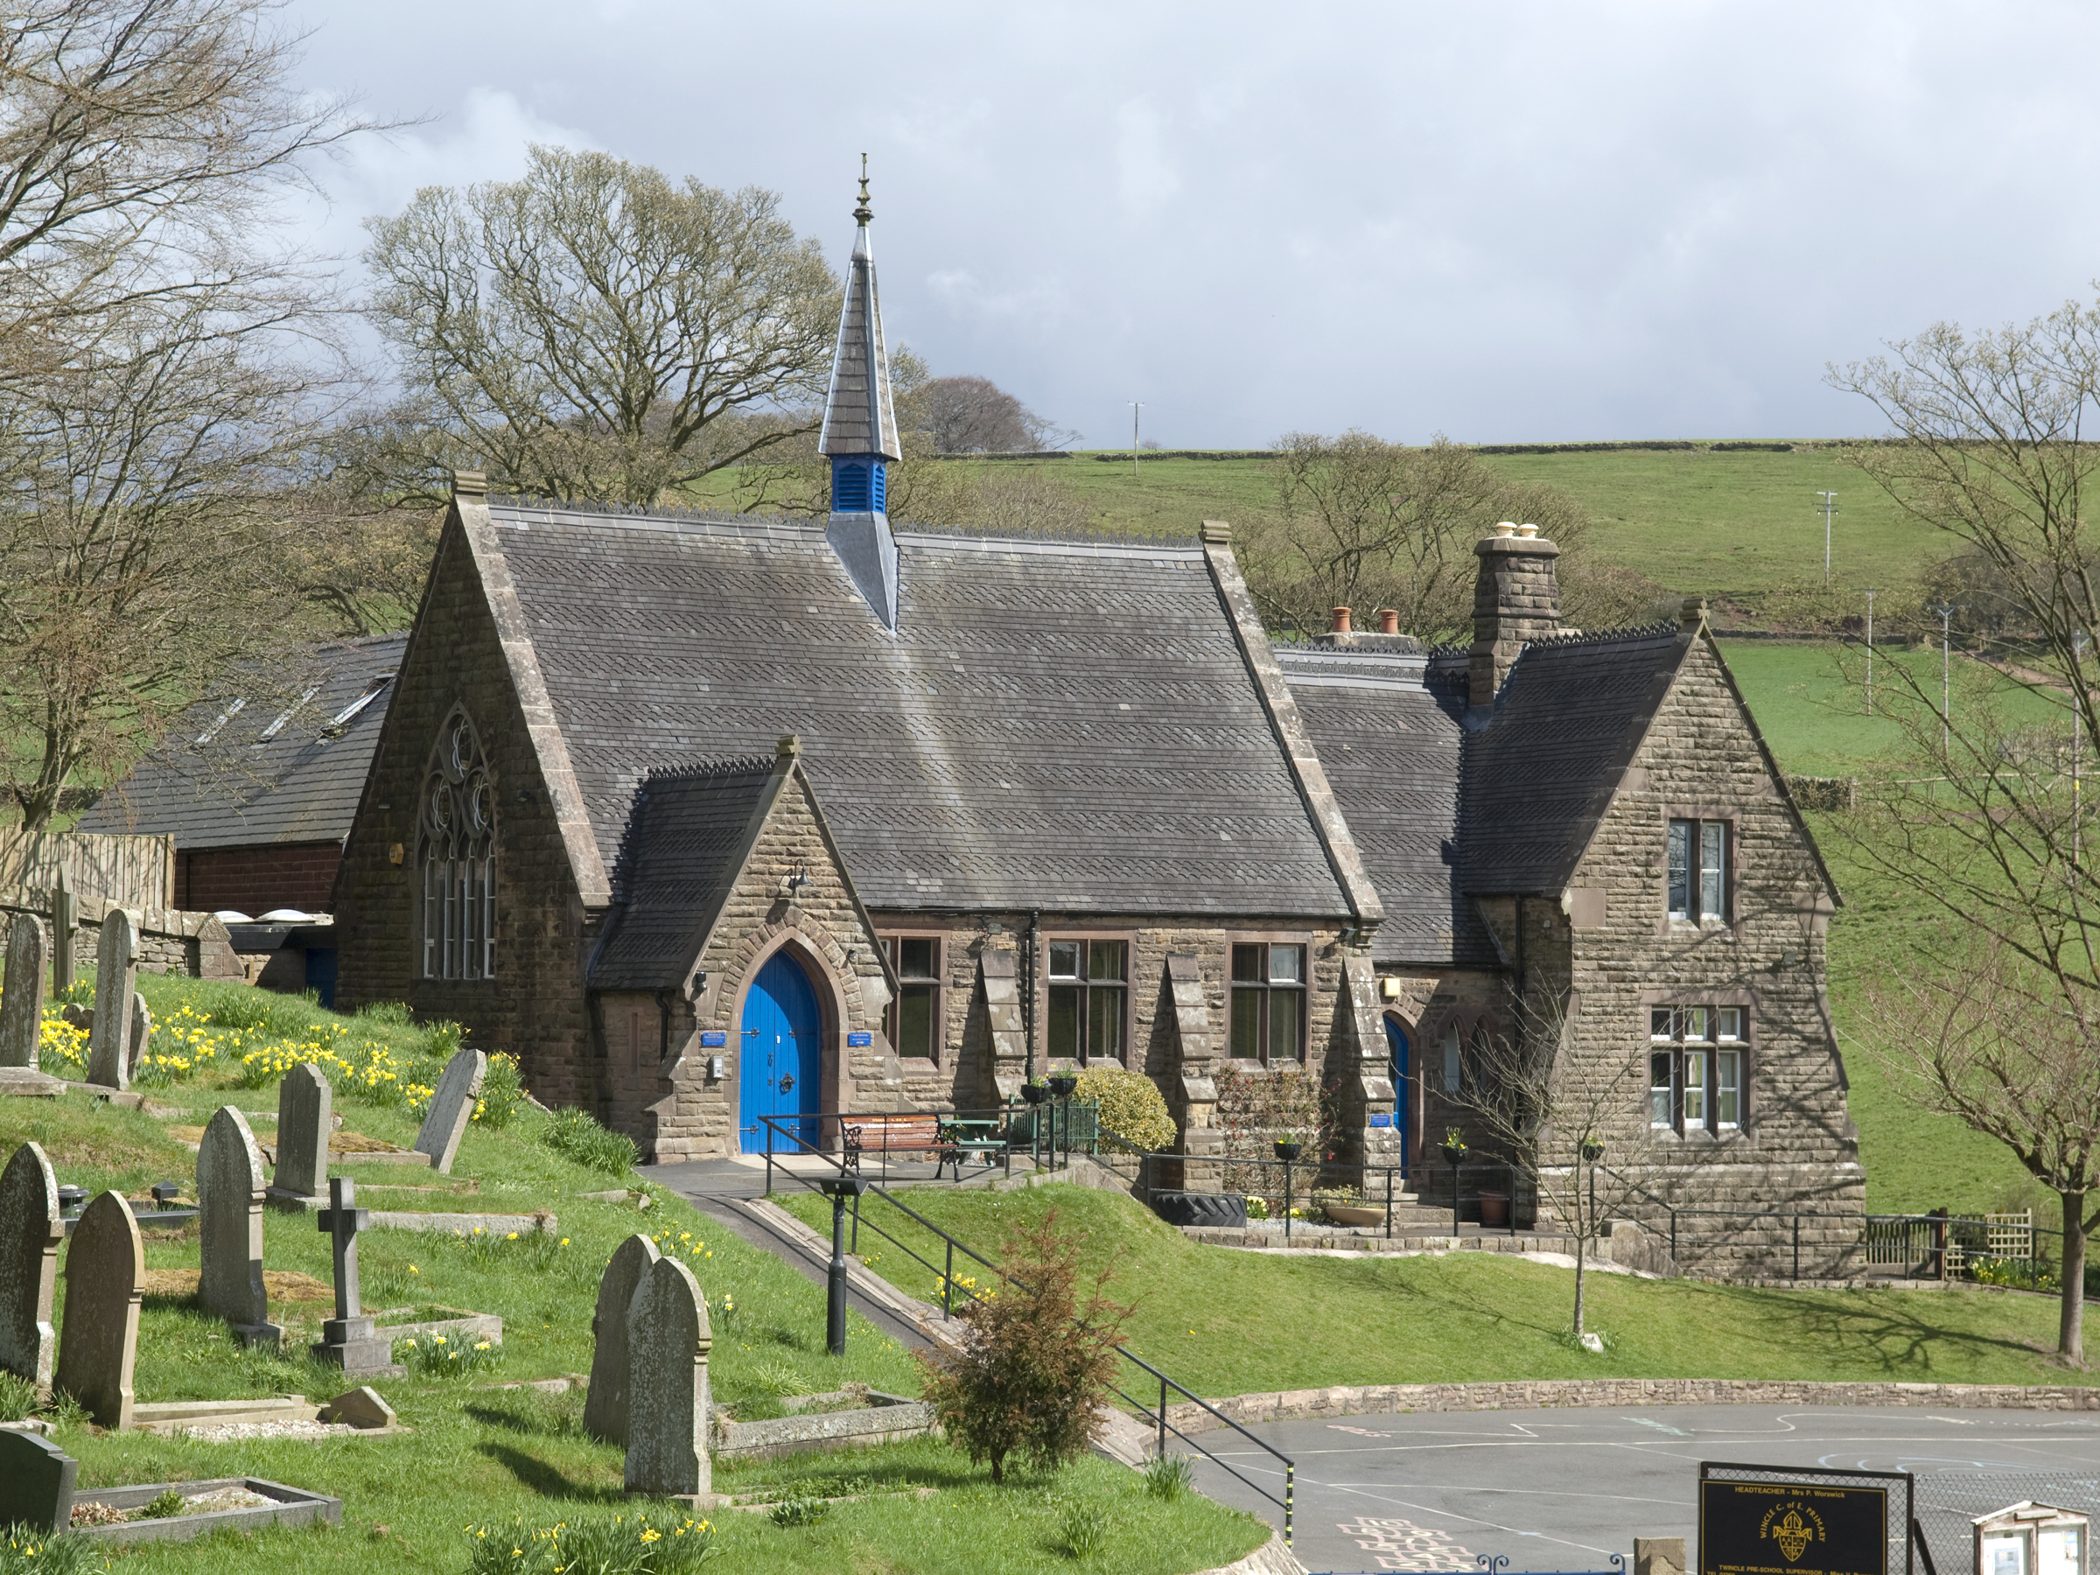
Wincle CE Primary School

Wincle
Nr Macclesfield
Cheshire
SK11 0QH
Tel: 01260 387387
Chair of Governors: Dr John Miller
admin@wincle.cheshire.sch.uk
www.wincleprimaryschool.org

Wincle School Holiday Dates 2022/2023

These dates are set by Cheshire East Council. We have aligned inset days as closely as possible the local Secondary Schools

Holiday | Close | Open
Summer 2022 |  | Monday 5th September 2022
October Half Term | Friday 21st October 2022 | Monday 31st October 2022
Christmas | Friday 16th December 2022 | Wednesday 4th January 2023
February Half Term | Friday 17th February 2023 | Monday 27th February 2023
Easter | Friday 31st March 2023 | Monday 17th April 2023
May Half Term | Friday 26th May 2023 | Tuesday 6th June 2023
Summer 2021 | Thursday 20th July 2023

.
Inset Days
Thursday 1st September 2022
Friday 2nd September 2022
Tuesday 3rd January 2023
Monday 5th June 2023
Friday 21st July 2023

Bank Holidays
Monday 2nd January 2023
Monday 1st May 2023

