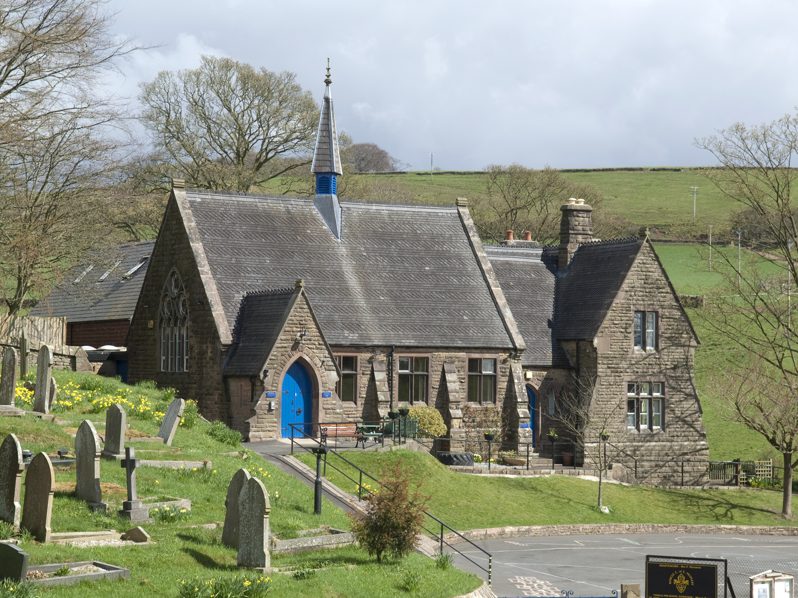
Wincle CE Primary School

Wincle
Nr Macclesfield
Cheshire
SK11 0QH
Tel: 01260 387387
Chair of Governors: Dr John Miller
admin@wincle.cheshire.sch.uk
www.wincleschool.org

Special Educational Needs Annual Report
(January 2024)

As part of their statutory duties, Governing Boards must publish information about and report on, the schools Special Educational Needs (SEN) policy.

The Special Educational Needs Co-ordinator is Miss Emma Jones and the named governor for SEN is Mrs Amy Henshaw

Number of Children with SEN

- 66 children on roll
- 15 children on SEND Register (23%)
- 5 children have an EHCP (8%)
- 9 children are on SEN Support (14%)
- 1 children have been identified as SEN Monitor through having additional need (2%)
- 7 children are in receipt of a ‘First Concerns’ profile (11%)
- 3 Pupil Premium children in school (5%)

National average |  | Cheshire East | Wincle
EHCP | 4% | unknown | 8% | 8 children
SEN Support without EHCP | 12.6% | unknown | 14% | 9 children
SEN Monitor |  |  | 2% | 1 child

SEN Policy
The school’s SEN policy was reviewed in November 2023 and is in line with the new Code of Practice (2014).

External Agencies
The following external agencies have supported SEN pupils throughout the year:
• Educational Psychology (EP)
• Speech and Language Therapists
• Occupational Therapists
• Cheshire East Autism Team (CEAT)
• School Nurse
We have also accessed support through the Barriers to Learning SENCO cluster meetings, CEAT meetings and EP meetings.

Progress of Pupils with SEN
All of the children who are on our SEN register have a School Focus Plan in place. They currently receive support that is different from and additional to their cohort, in order to meet their individual targets.

Before a pupil is placed on the SEN register, their parents are notified and the reasons for doing so are discussed. Parents are then involved in writing their child’s School Focus Plan. Parents will be invited to attend termly progress meetings where they will be able to contribute to their child’s targets.

All classrooms have an SEN file where relevant information is recorded. Provision and interventions are documented in the files which are regularly monitored by the SENCO/Head teacher. Initial assessments have taken place so that current interventions can be successfully monitored and evaluated throughout the year.

Budget Allocation
We have five pupils who receive additional funding, with a total of funded support being145.5 hours.
Deployment of Staff and Resources
Teachers and teaching assistants work with individual pupils or small groups of pupils, following a variety of support interventions. Not all of the pupils receiving interventions are on the SEN register but they have been identified as needing additional support in specific areas. Where possible, we aim to support children within the classroom, however this is not always possible.

Working with Parents
Wincle CE Primary School operates an open-door policy and any initial concerns can be discussed with class teachers. Parents are also actively encouraged to engage with school through parent consultation meetings.

Attendance
Attendance is monitored by Admin and the Head teacher on a weekly basis. Our policy sets out a process for addressing any concerns and offering support to families to improve attendance.
Links to other Schools
The SENCO has established strong links with a number of professionals at our cluster primary schools. She attends regular meetings to discuss current provision and moderates SEN practice frequently.

Staff Development
The SENCO, Teachers and Teaching Assistants meet regularly to discuss pupils, intervention programmes and resources. Staff complete record sheets about the interventions taking place and the progress of pupils is monitored regularly.

