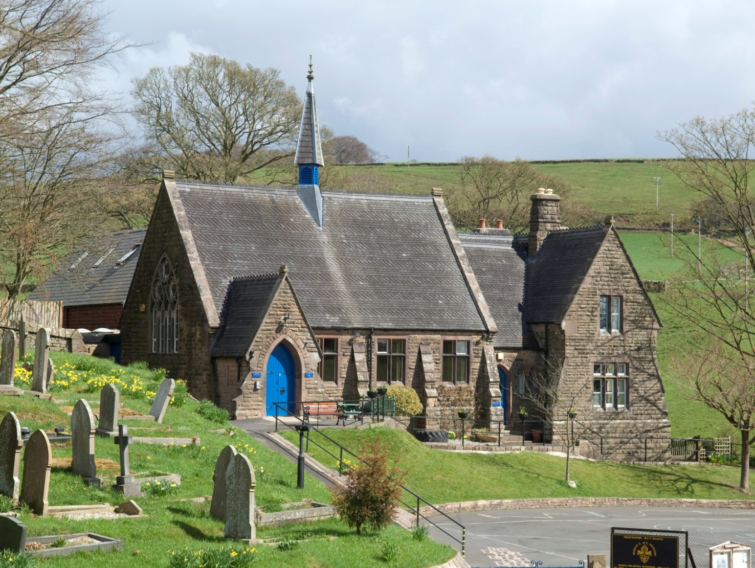



**Admissions Policy 2025**

**Wincle CE Primary School**

Version: approved

Date: November 2023

**Wincle CE Primary School**

**Wincle**

**Macclesfield**

**Cheshire**

**SK11 0QH**

**Tel: 01260 212592**

**Headteacher: Mrs S Smith**

**Chair of Governors: Dr J Miller**

**www.wincleprimaryschool.org**

**Version control**

|  |  |
| --- | --- |
| **Date updated:** | **Brief summary of changes:** |
| November 2023 | Date of policy adapted throughout the policy. |

Our school’s vision:

Wincle School creates an enriching and outstanding rural education, nurturing the whole individual: body, mind and soul, inspiring rounded, happy, courageous children who exhibit a passion for learning, a confident faith, a loving concern for community and an inclusive respect for all.

We encourage our pupils to ‘Shine like Stars’ (Philippians 2:15) and to do this run with the following acronym:



Parents should be aware before applying that in this school RE, collective worship and our whole ethos are based on the teachings of the Church of England.

Applications for admission to the school for September 2025 should be made on the common application form enclosed with the Local Authority’s brochure and also on the School’s supplementary form by those applying under criteria 5 between 1st September and 15thJanuary as stated on the Cheshire East website <http://www.cheshireeast.gov.uk/schools/admissions/admissions.aspx>

Applications may also be made on-line by using both the common application form and the Supplementary Form. It is not normally possible to change the order of your preferences for schools after the closing date. Whether an application is made on paper or electronically, both forms should be completed by those applying under criteria 5 (failure to complete the supplementary form may result in the application being assessed against a lower criterion due to lack of information).

Written offers informing parents of whether or not their child has been allocated a place will be sent out by the Local Authority on 16th April. Letters will be sent as a result of late applications or paper applications. Parents of children not admitted will be informed of the reason and offered an alternative place by the Authority.

The number of places available for admission to the Reception class in the year 2025 will be a maximum of **8.** This arrangement follows consultation between the governing body, the Diocesan Board of Education, Local Authorities and other admissions authorities in the area. By law, no infant class may contain more than thirty children.

The Governing Body operates a system of equal preferences under which they consider all preferences equally and the Local Authority allocates places according to its policy. In the event that there are more applicants than places, the governing body will allocate places using the following criteria, which are listed in order of priority:

1. Looked after children and all previously looked after children, **including those children who appear (to the admission authority) to have been in state care outside of England and ceased to be in state care as a result of being adopted**
2. Children with special medical or social circumstances affecting the child where these needs can only be met at this school. (a)
3. Children resident in the catchment area for Wincle school which includes the parishes of Wincle, Wildboarclough and Macclesfield Forest. A map is attached to this policy. (b)
4. Children who have a sibling (brother or sister) at Wincle school who will still be attending Wincle school the following year. (c)
5. Children whose parents are faithful and regular members of church that is a member of Churches Together in Britain or Ireland. (d)
6. Children who live nearest to the school – priority will be decided on the basis of the distance from the school to home measured “Pupils living nearest to the school measured using the National Land and Property Gazetteer (NLPG) which measures straight line distances in miles from the school’s coordinate point to the point of residence’s coordinate point”

**Notes**

1. Professional supporting evidence from e.g. a doctor, psychologist, social worker, is essential if admission is to be made under the criterion for special medical or social circumstances, and such evidence must set out the particular reasons why the school is question is the most suitable school and the difficulties which would be caused if the child had to attend another school.
2. A map showing the boundaries is available from school and below this policy.
3. Siblings include step, half, foster, adopted brothers and sisters living at the same address and full brother and sister living apart.
4. By “faithful and regular” we mean attendance at a minimum of two services per month for at least six months prior to the closing date for applications. The supplementary form will need to be completed and signed by the incumbent, minister or other church officer. Where admission arrangements refer to ‘parent’s attendance at church’, it is sufficient for just one parent to attend. A parent is any person who has parental responsibility or care of the child.
5. All children with a 4th birthday between 1st September 2024 and 31 August 2025 are admitted in September 2025. For children with a 5th birthday after Christmas or after Easter, parents may defer entry until later in the year but not beyond the point at which they reach compulsory school age. The head teacher should be consulted if this option is being considered. See deferred admission guidance below.

**Admissions information:**

Last year, the school was able to admit all pupils whose parents applied.

**Late applications for admission**

Applications received after the closing date will be recorded as ‘late’ and considered after all on-time applications unless the Local Authority confirms that the reasons presented in support of the late submission justify the application being considered alongside on-time applications. Reasons can include exceptional medical reasons preventing an earlier application or late removal into the area. Reasons must be presented at the time of application and supporting documentation **must** be provided, which must be received by the dates specified. Or reference Coordinated scheme on LA website

Otherwise, applications which are received after the last date will be considered after all the others, and placed on the waiting list in order according to the criteria.

**Waiting list**

Where we have more applications than places, the admissions criteria will be used. Children who are not admitted will have their name placed on a waiting list. The names on this waiting list will be in the order resulting from the application of the admissions criteria. Since the date of application cannot be a criterion for the order of names on the waiting list, late applicants for the school will be slotted into the order according to the extent to which they meet the criteria. Thus/ it is possible that a child who moves into the area later to have a higher priority than one who has been on the waiting list for some time. If a place becomes available within the admission number, the child whose name is at the top of the list will be offered a place. This is not dependent on whether an appeal has been submitted.

This waiting list will operate until 31st December.

**Address of pupil**

The address used on the school’s admission form must be the current one at the time of application. If the address changes subsequently, the parents should notify the school. Where the parents live at different addresses, the current-at-the-time-of-application, normal address of the child will be the one used. This will normally be the one where the child wakes up for the majority of Monday to Friday mornings. Parents may be asked to show evidence of the claim that is being made for the address, utility bills of various sorts showing the child’s address as the one claimed. Where there is dispute about the correct address to use, the governors reserve the right to make enquiries of any relevant third parties, e.g. the child’s GP. For children of UK Service personnel and other Crown Servants returning to the area proof of the posting is all that is required.

**Key dates-** these can be found on the Cheshire East admissions website in Applying for School Places booklet or Co-ordinated scheme

**Non-routine admissions**

If a parent wishes to apply for a place at the school outside the normal admission round (known as in-year admission) they can apply via CEC website [http://www.cheshireeast.gov.uk/schools/admissions/in_year_admissions.aspx](https://remote.cheshire.gov.uk/owa/head@wincle.cheshire.sch.uk/,DanaInfo=.aoxcfpzy0m0Jz64qwu9z1.zVz01IH6IKe8JI+redir.aspx?REF=T-ute8DSIhGFzu-pNvDaow7Koc6D70LiF0QC7fmL4COpuWUt7ZLUCAFodHRwOi8vd3d3LmNoZXNoaXJlZWFzdC5nb3YudWsvc2Nob29scy9hZG1pc3Npb25zL2luX3llYXJfYWRtaXNzaW9ucy5hc3B4)

**Appeals**

Where the governors are unable to offer a place because the school is over subscribed, parents have the right to appeal to an independent admission appeal panel, set up under the School Standards and Framework Act, 1998, as amended by the Education Act, 2002. **Parents should notify the clerk to the governors at the school within 20 days of receiving the letter refusing a place**. Parents will have the opportunity to submit their case to the panel in writing and also to attend in order to present their case. You will normally receive 10 days’ notice of the place and time of the hearing.

If your child was refused a place in Reception or Key Stage 1 because of Government limits on Infant class sizes, the grounds on which your appeal could be successful are limited. You would have to show that the decision was one which in the circumstances no reasonable governing would have made, or that your child would have been offered a place if the governors’ admissions arrangements had been properly implemented.

**Please note that this right of appeal against the governors’ decision does not prevent you from making an appeal in respect of any other school.**

**Fraudulent applications**

Where the governing body discovers that a child has been awarded a place as the result of an intentionally misleading application from a parent (for example a false claim to residence in the catchment area or of involvement in a place of worship) which effectively denies a place to a child with a stronger claim, then the governing body is required to withdraw the offer of the place. The application will be considered afresh and a right of appeal offered if a place is refused.

**Repeat Applications** Repeat applications will not be considered within the same school year, unless the

circumstances for the parent or school have changed significantly since the original application was made.

Full details must be provided to the Local Authority for consideration.

**Tie Breaker**

Distance criterion will be applied as a tie breaker if the number of pupils applying under criterion

(ii) exceeds the number of available places. To differentiate betweentwo equal distance

measurements, a random allocation tie-breaker will be applied. This will be administered under

independent supervision, in accordance with the requirements of the School Admissions Code at

paragraph 1.35.

**Deferred admission**

If your child is due to start school during the next academic year, it is important that you apply for a place for September. If your child’s fifth birthday is between the months of September and December, then, if you wish it, admission may be deferred until January; if it is between January and April, then admission may be deferred until the start of the summer term.

**Children educated outside their age group**

Parents of summer born children (those born between 1st April and 31st August) who wish to delay entry until the following year, must speak to the school and Local Authority as soon as possible as this would involve either an in-year application for year 1 or a new application for reception in the following year. An application form should be filled in for the current admission process at the same time as any request to defer entry or ‘back class’ to reception in the following year. The decision will be made taking into account information from the parents and head teacher and should be in the best interests of the child. Parents will be informed of the outcome before primary national offer day.

If the request is agreed, the application for the normal age group may be withdrawn before a place is offered. If the request is refused, the parent must decide whether to accept the offer of a place for the normal age group, or to refuse it and make an in-year application for admission to year one for the September following the child’s fifth birthday.

Parents should be aware that agreement by the school to allow a child to enter reception the following year does **not** guarantee a place in the class. Parents must apply to the school again the following year and the application will be considered in the normal manner following the oversubscription criteria.

**Twins/multiple births**

Where there are children of multiple births wishing to be admitted and the sibling is the 30th child, the governors may admit over the infant class requirement if it is possible to do so.

**Special Educational Needs**

Where a child has an education, health and care plan (EHCP) which names the School, then that child will be admitted to the School and the number of available places in the PAN will reduce correspondingly. Admission of children with an EHCP is dealt with by the home Local Authority (LA) (which is where you reside).

**Fair Access Protocol** – the school participates in Cheshire East Local Authority Fair Access Protocol

**Supplementary form**By “faithful and regular”, we mean attendance at a minimum of two services per month for at least six months prior to the closing date for applications. This supplementary form will need to be completed and signed by the incumbent, minister or other church officer. Where admission arrangements refer to ‘parent’s attendance at church’, it is sufficient for just one parent to attend. A parent is any person who has parental responsibility or care of the child.

**Name of child**:

|  |  |  |  |  |  |  |
| --- | --- | --- | --- | --- | --- | --- |
| Surname |  | Christian names | |  | | |
| Date of birth |  | Boy |  | | Girl |  |

|  |  |  |  |  |  |
| --- | --- | --- | --- | --- | --- |
| **Name of parent/guardian** | | |  | | |
| Address |  | | | | |
| Post code | |  | | | |
| Telephone | |  | | Mobile |  |

**Place of worship** one of parents / guardians regularly attends:

|  |  |  |  |  |  |  |
| --- | --- | --- | --- | --- | --- | --- |
| Name of place of worship | | |  | | | |
| Address | |  | | | | |
| Name of vicar / priest / minister / faith leader / church officer | | | | | |  |
| Address |  | | | | | |
| Post code | |  | | Telephone |  | |

**Worship attendance**:

|  |  |  |  |  |  |  |
| --- | --- | --- | --- | --- | --- | --- |
| I/we have attended worship at least twice a month for the past six months? [tick one box only] | | | | | | |
| yes |  | no |  |  |  |  |

Your faith leader will be contacted in order to confirm this information.

Parish Map:

